Vacuum furnace in construction at Physimeca

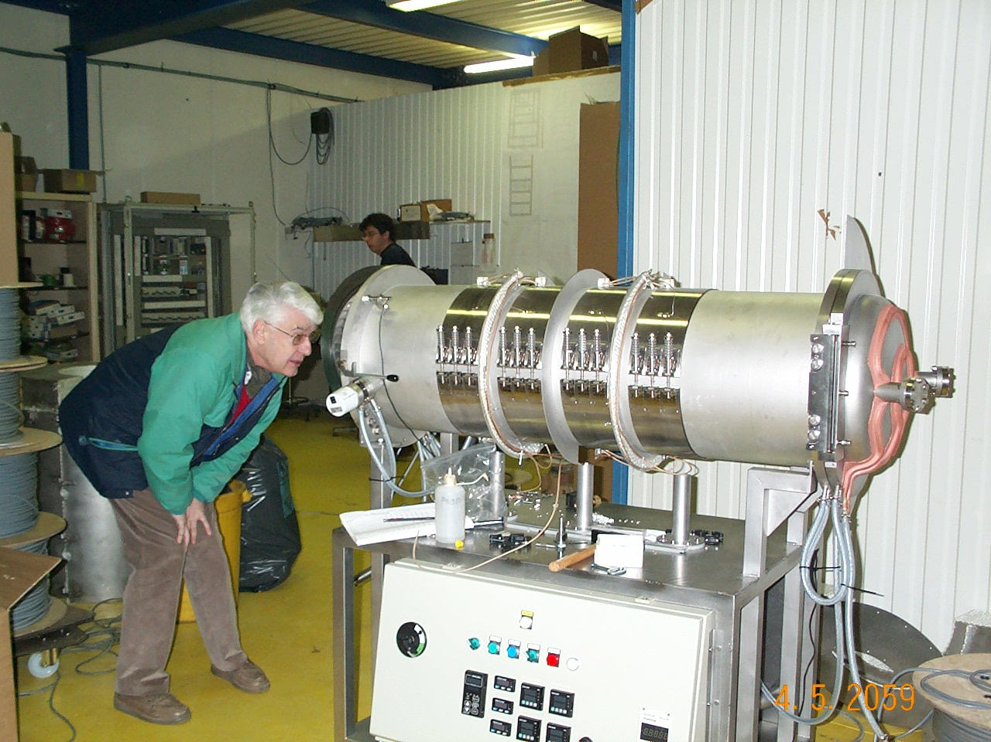
Schematic of the TTF-4 Coupler
(RF design – B. Dwersteg/DESY, mechanical conception – L. Grandsire, F. Rudnyckyj/LAL)

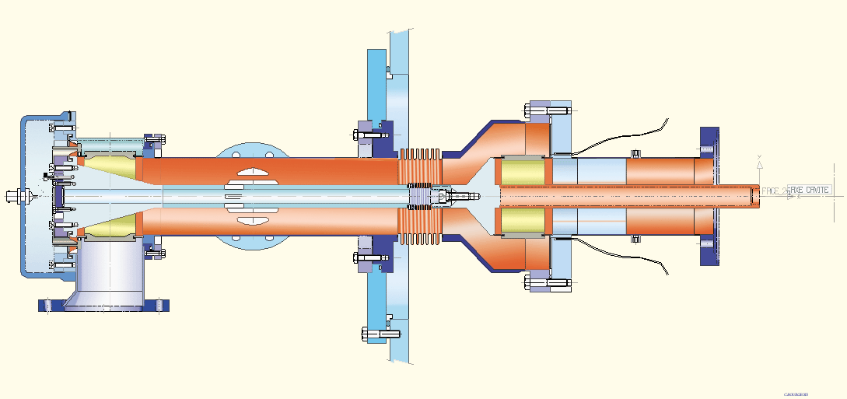
Ceramic windows brazed to their copper collars.

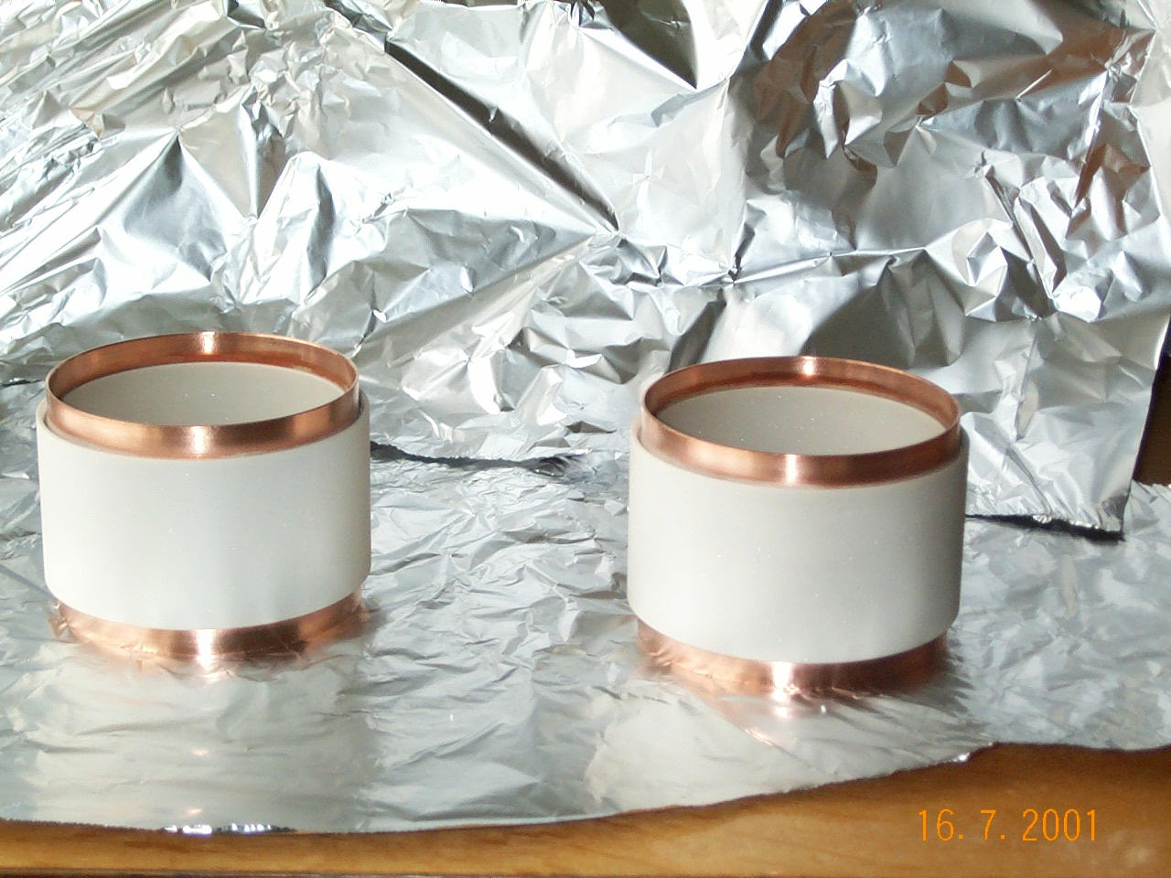
TTF-4 Ceramics receiving their Titanium Nitride deposition
(J. Lorkiewicz / DESY)

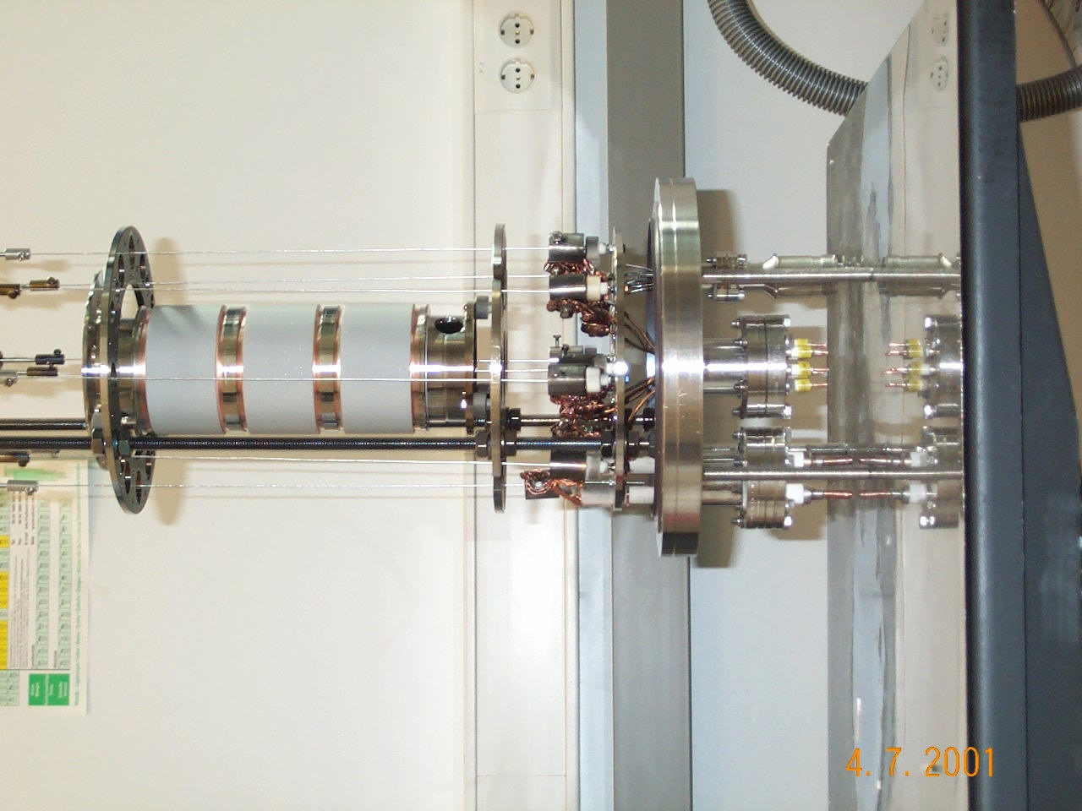
Copper coated inner bellow (Galion)

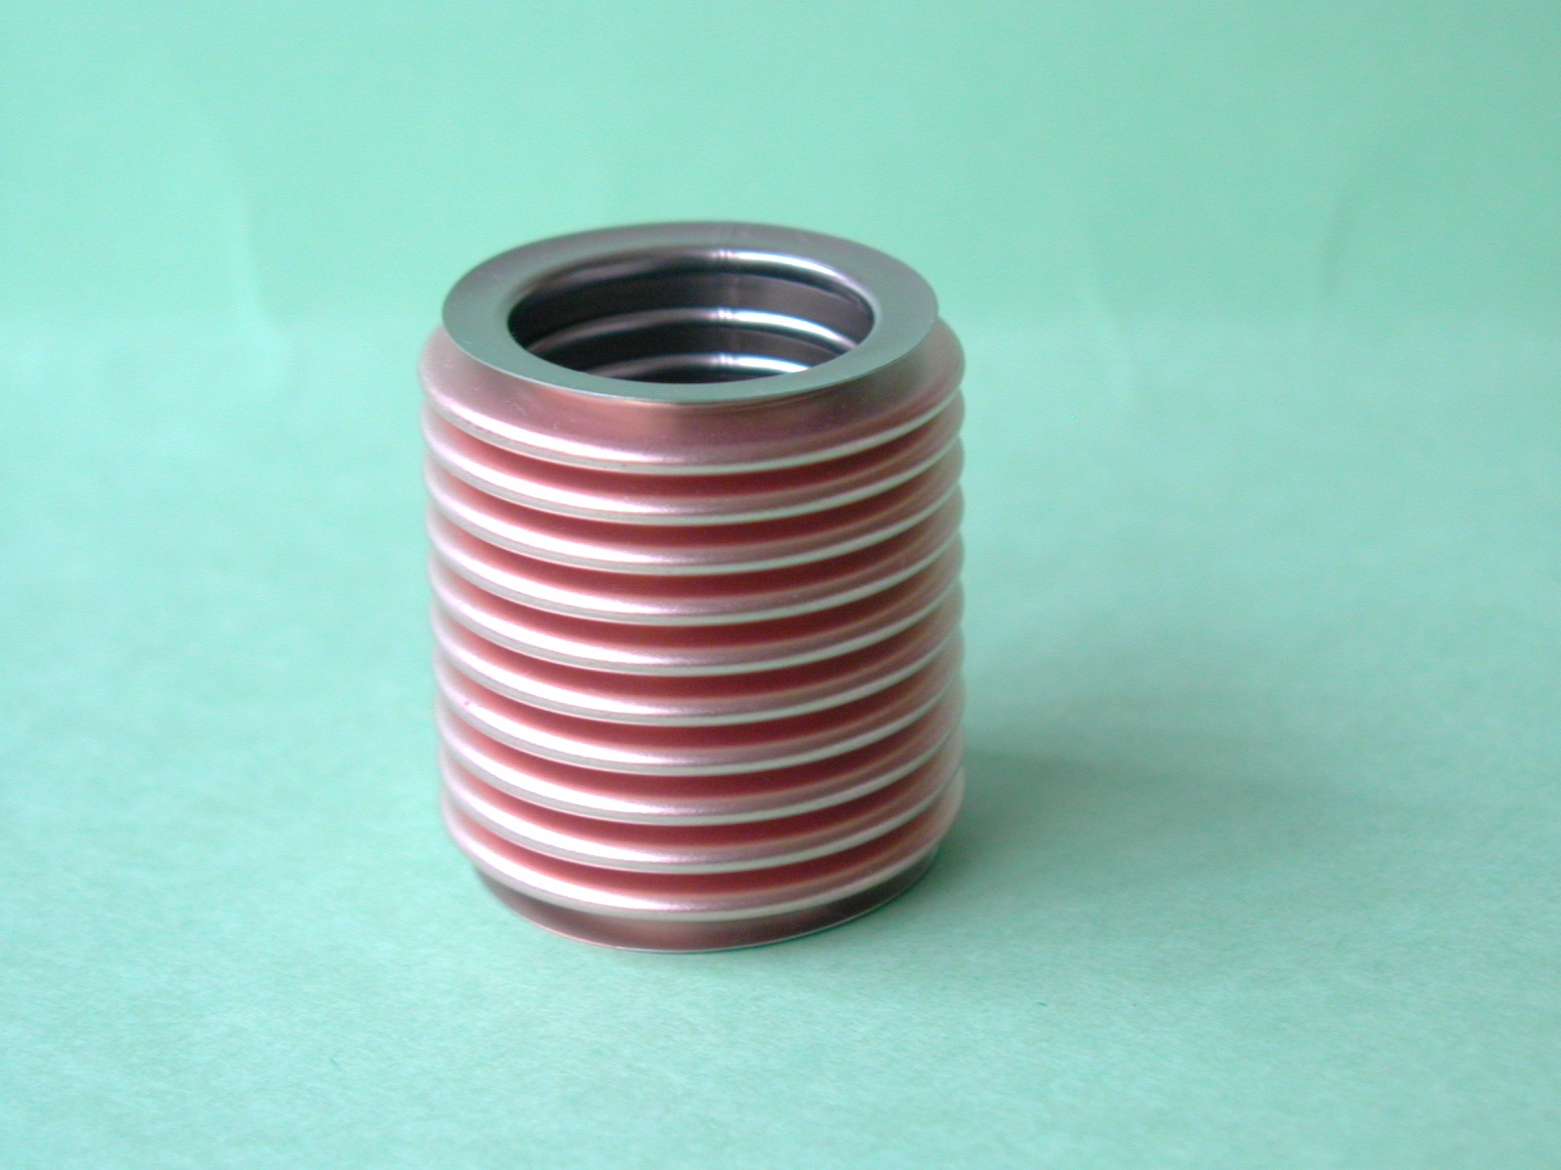
Magnified image of copper coating (W. Singer / DESY)

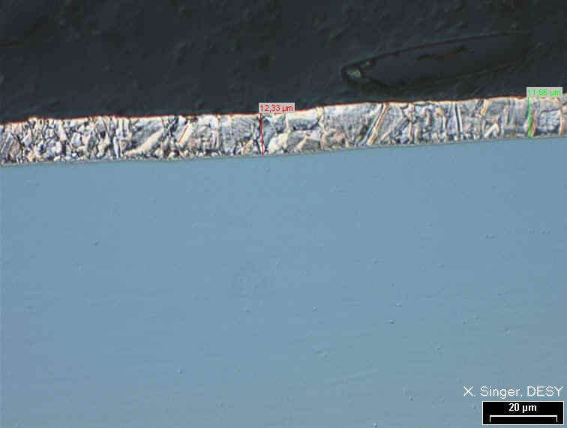

Warm coupler part (SNLS)

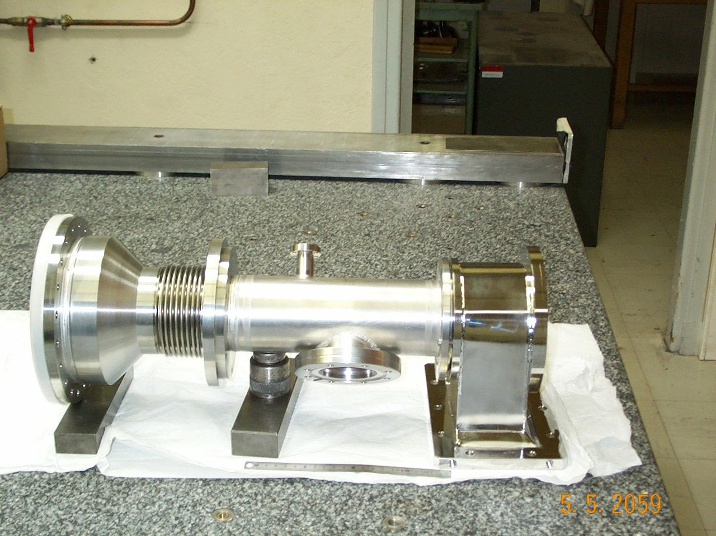

Cold coupler part (SNLS)

